**CHAPTER 2.0**

**PROJECT MANAGEMENT**

**2.1 PROJECT PLANNING**

I have divided the project into individual modules which have unique constraint limited functionalities which will be further explained. The estimated project development period has been 3 months. The project team consists of 1 key members.

**2.1.1 Project Development Approach and Justification**

For the project development the approach I have made was using Iterative waterfall model. In iterative development, first of all feature code is designed, developed and then tested in repeated cycles. With each iteration additional features can be designed, developed and tested until there is a fully functional product which is ready to use.

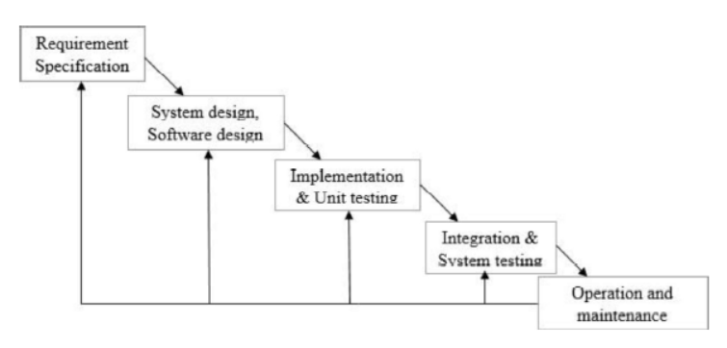

Figure 2.1 - Iterative waterfall model

The project IPL Winner Prediction is used Machine learning algorithms for predict the winner of match using previous data. Front end design is done using HTML, CSS, JavaScript and jquery. I used Flask framework for the actual backend system. For this project I have to use various machine learning algorithm and fand the best algorithm for this project. I needed to run and test that particular module and then respective changes were to be made and new features were to be added. I found Iterative waterfall model to be the best to follow for my project.

**2.1.2 Roles and Responsibilities**

|  |  |  |
| --- | --- | --- |
| **Student ID** | **Student Name** | **Role** |
| 17CE037 | Rohan Jethloja | Full stack Developer |

Table 2.1 Roles and Responsibilities

**2.2 PROJECT SCHEDULING**

The Project Scheduling will be initially explained by the help of WBS (Work Breakdown Structure). The Work Breakdown Structure is a hierarchical reflection of all the work in the project in terms of deliverables. In order to produce these deliverables work must be done. A typical approach in developing a WBS is to start at the highest level, with the product of the product of the project

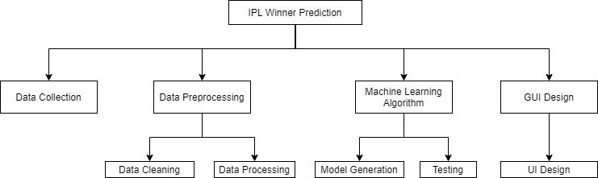

Figure 2.2 – Work Breakdown Structure